Assignment -2
Python Programming

Assignment Date | 24 September 2022
Student Name | S.V.Subushri
Student Roll Number | 2019504052
Maximum Marks | 2 Marks

Question:
Build a Python code, assume you get temperature and humidity values (generated with random function to a variable) and write a condition to continuously detect alarm in case of high temperature.

Solution:

import random
import time

i=0
while(i<5):
temp = random.randrange(0,75)
mois = random.randrange(0,120)
print(temp," ",mois,"%")
if(temp > 50):
print("High Temperature")
elif(temp < 10):
print("Low Temperature")

if(mois > 80):
print("Very Humid Weather")
elif(mois < 20):
print("Very Dry Weather")

i+=1
time.sleep(2)

Code:

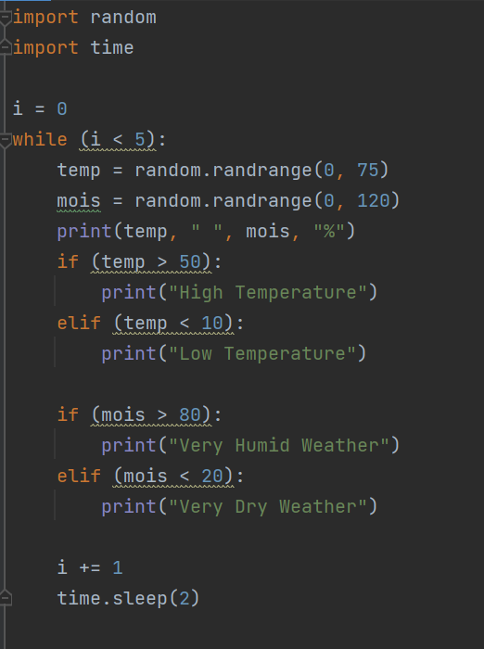

Code Result:

